

**Bank Marketing Analytics**

***Wireframe Documentation***

**Data Visualization using Power BI**

During Exploratory Data Analysis, Following insights has been found which are given below:

1. **Deposit Vs Age (Actual Values)**

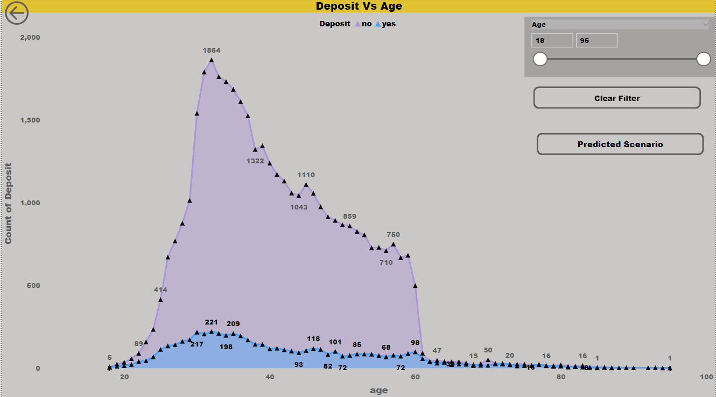

From the Above Insight, It States that: In Deposit Vs Age Plot, Age 32 is the Highest Depositor with 221 deposit .

1. **Deposit Vs Age (Predicted Values Random Forest and XG Boost)**

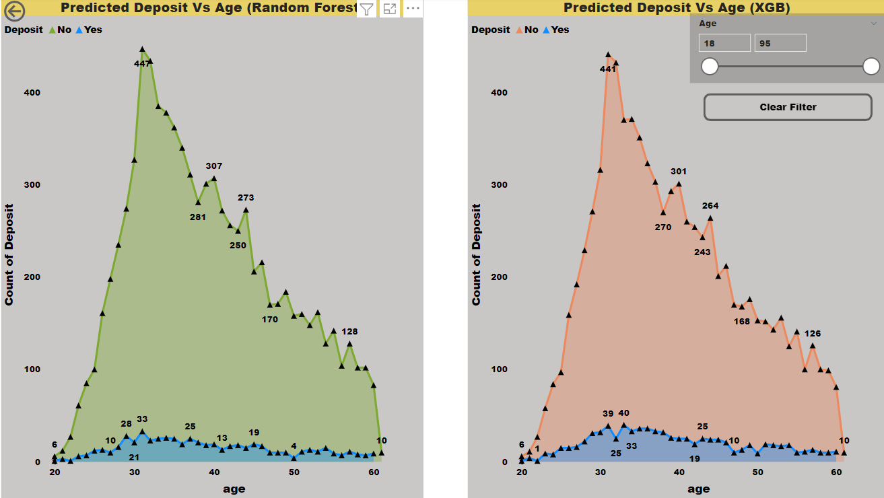

From the Above Insight, It States that: In Deposit Vs Age Plot, Random Forest Model predicted as Age 31 is the Highest Depositor with 33 deposit and XG Boost Model predicted as Age 31 is the Highest Depositor with 39 deposit.

1. **Deposit Vs Job (Actual Values)**

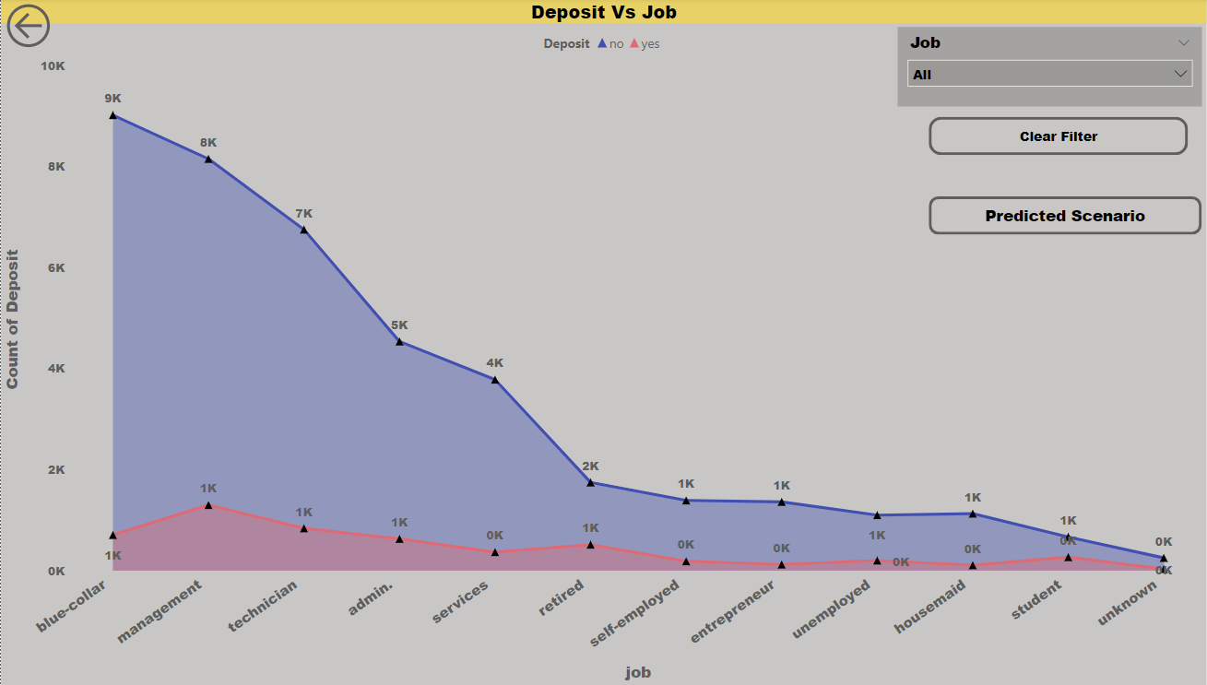

From the Above Insight, It States that: In Deposit Vs Job Plot, Blue Collar job is the Highest Depositor with 708 deposit.

1. **Deposit Vs Job (Predicted Values Random Forest and XG Boost)**

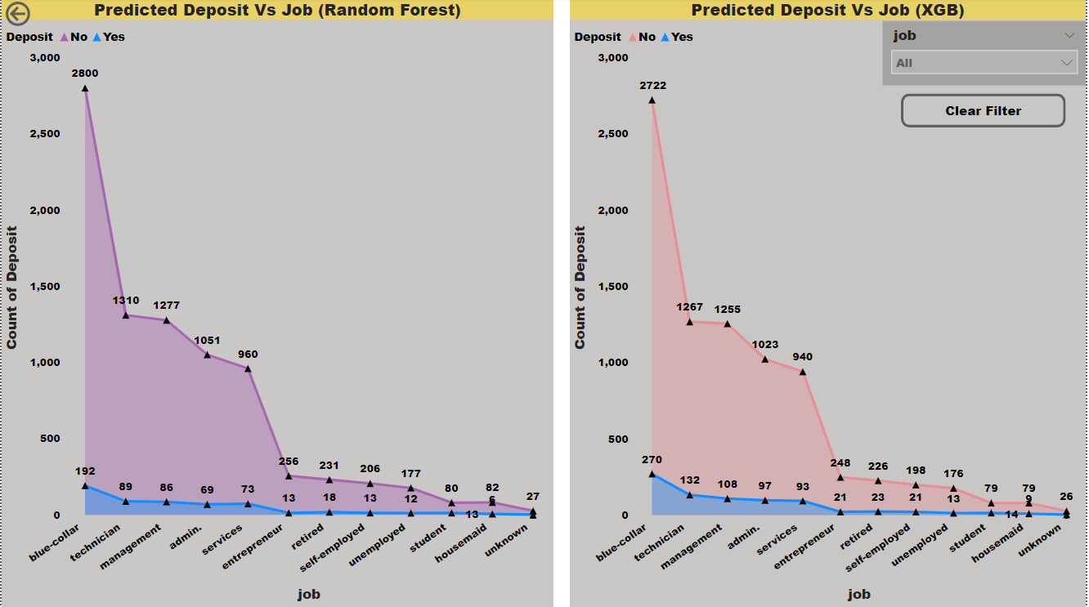

From the Above Insight, It States that: In Deposit Vs Job Plot, Random Forest Model predicted as Blue Collar job is the Highest Depositor with 192 deposit and XG Boost Model predicted as Blue Collar job is the Highest Depositor with 270 deposit.

(5) **Balance Vs Job Vs Deposit (Actual Values)**

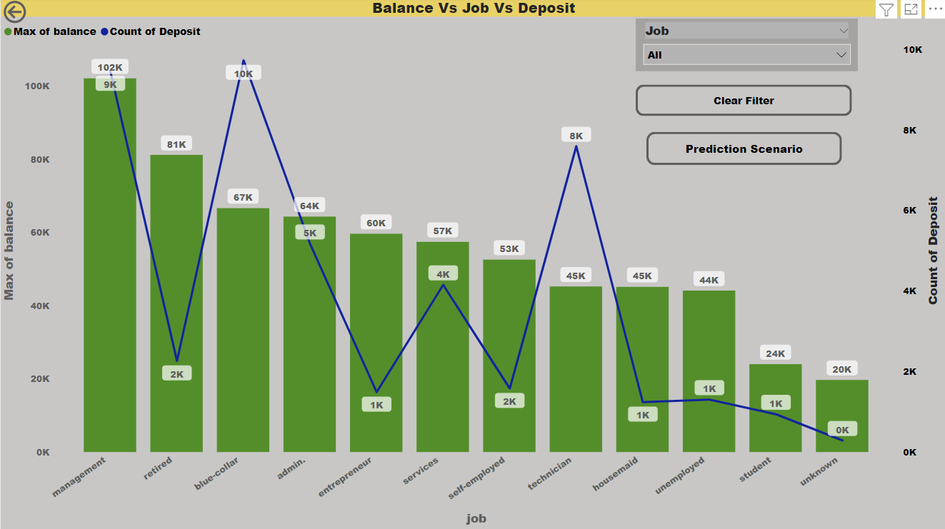

From the Above Insight, It States that: In Balance Vs Job Vs Deposit Plot, Management job has the Maximum Balance with 102127 Balance and Highest Depositor with 9458 deposit.

1. **Balance Vs Job Vs Deposit (Predicted Values Random Forest and XG Boost)**

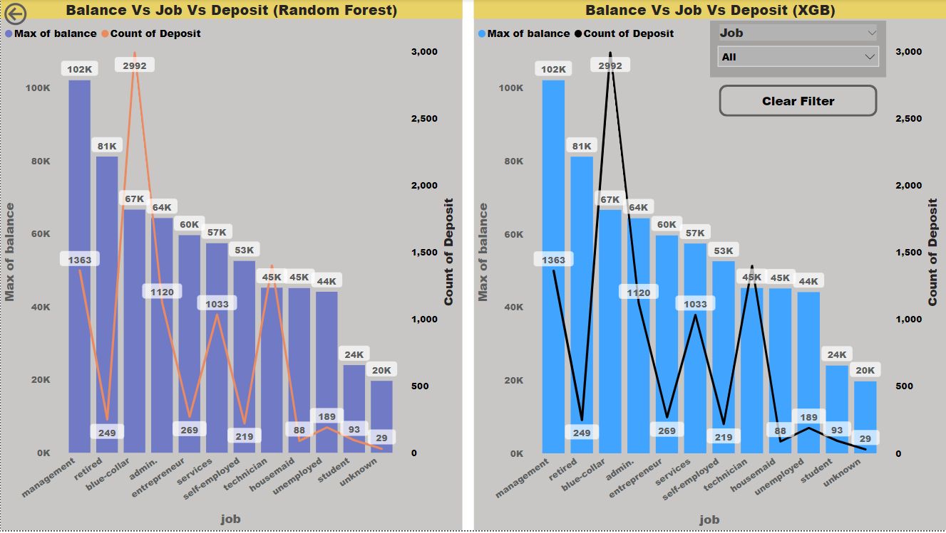

From the Above Insight, It States that: In Balance Vs Job Vs Deposit Plot, Random Forest Model predicted as Management job has the Maximum Balance with 102127 Balance and Highest Depositor with 1363 deposit and XG Boost Model predicted as Management job has the Maximum Balance with 102127 Balance and Highest Depositor with 1363 deposit.

1. **Deposit Vs Month (Actual Values)**

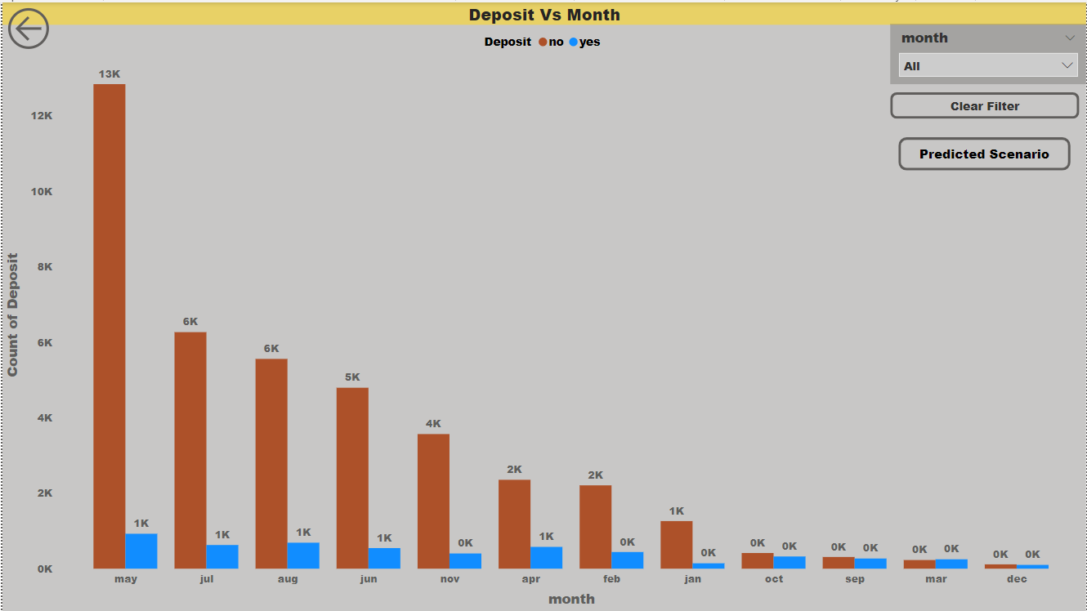

From the Above Insight, It States that: In Deposit Vs Month Plot, May Month has the Highest Depositor with 925 deposit .

1. **Deposit Vs Month (Predicted Values Random Forest and XG Boost)**

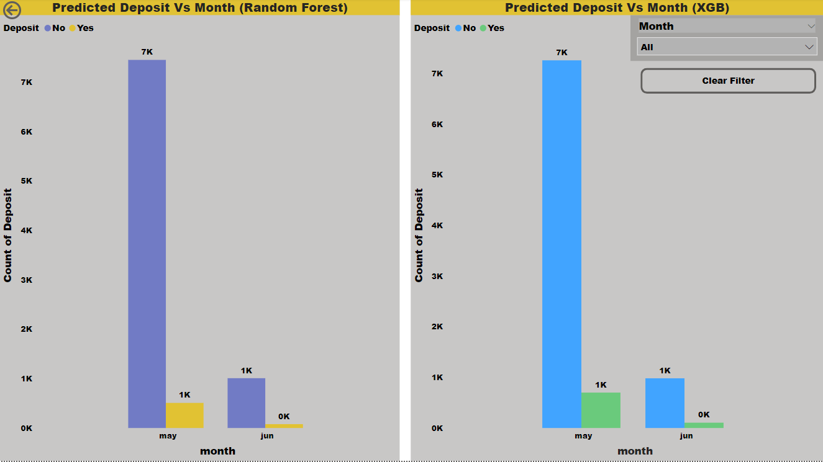

From the Above Insight, It States that: In Deposit Vs Month Plot, Random Forest Model predicted as May Month has the Highest Depositor with 508 deposit and May Month has the Highest Depositor with 699 deposit.

1. **Previous Marketing Campaign (Actual Values)**

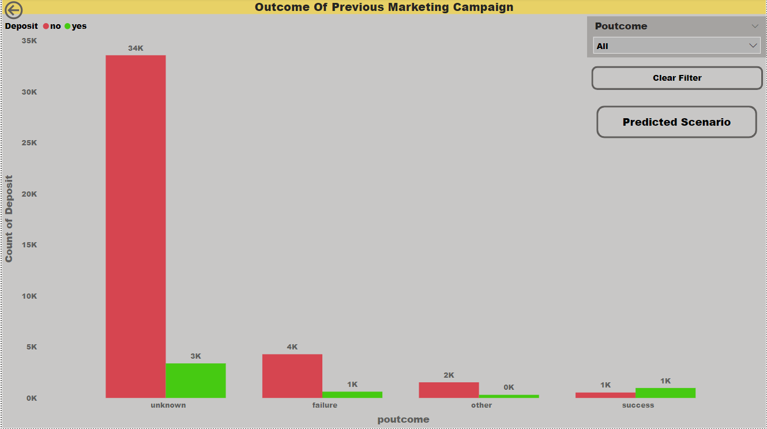

From the Above Insight, It States that: In Previous Marketing Campaign Plot, Unknown Category is the Highest Depositor with 3386 deposit.

**(10) Previous Marketing Campaign (Predicted Values Random Forest and XG Boost)**

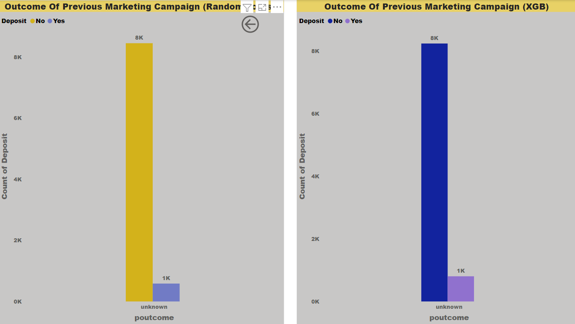

From the Above Insight, It States that: In Previous Marketing Campaign Plot, Random Forest Model predicted as Unknown Category is the Highest Depositor with 586 deposit and Unknown Category is the Highest Depositor with 804 deposit.

1. **Deposit Vs Month (Actual Values)**

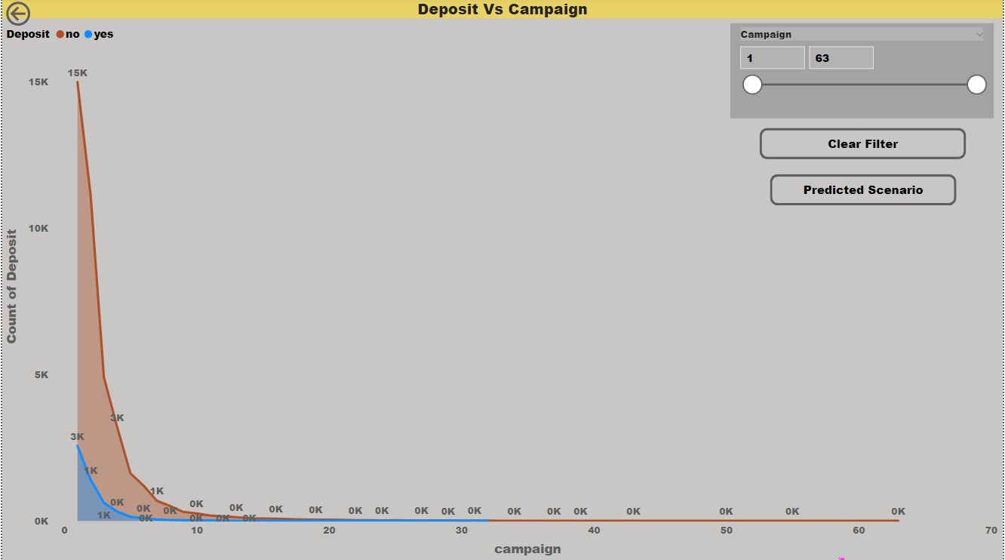

From the Above Insight, It States that: In Deposit Vs Campaign Plot, Day 1 has the Highest Depositor with 2561 deposit.

1. **Deposit Vs Month (Predicted Values Random Forest and XG Boost)**

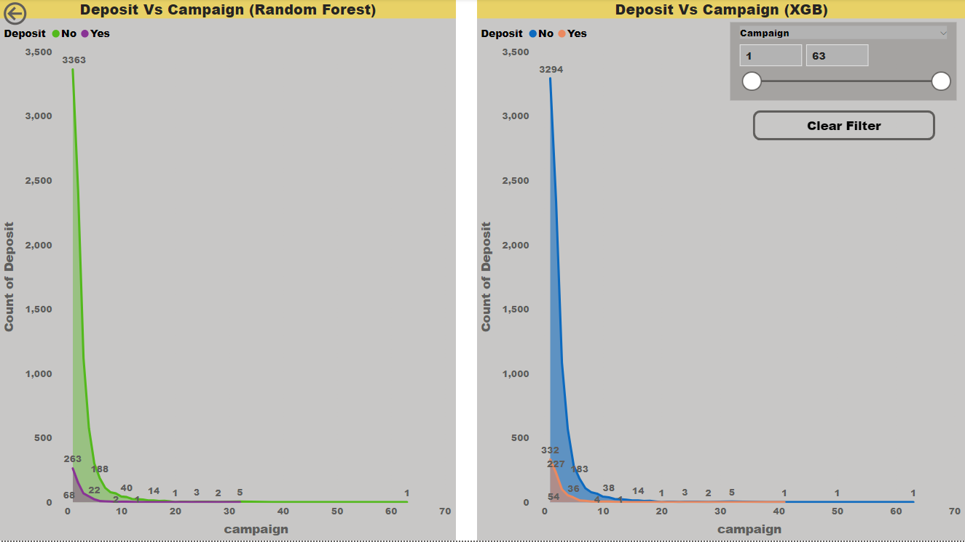

From the Above Insight, It States that: In Deposit Vs Campaign Plot, Random Forest Model predicted as Day 1 has the Highest Depositor with 263 deposit and XG Boost Model predicted as Day 1 has the Highest Depositor with 332 deposit.

1. **Deposit Vs Loan (Actual Values)**

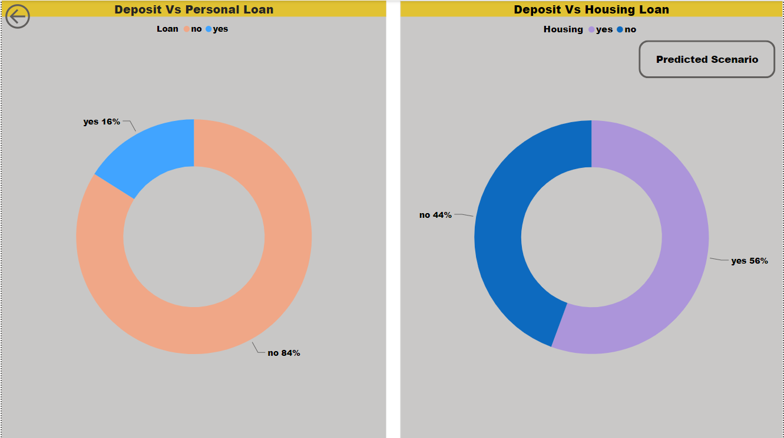

From the Above Insight, It States that: In Deposit Vs Personal Loan and Housing Loan Plot, 16% Personal Loan and 56% Housing Loan will be Deposited.

1. **Deposit Vs Loan (Predicted Values Random Forest and XG Boost)**

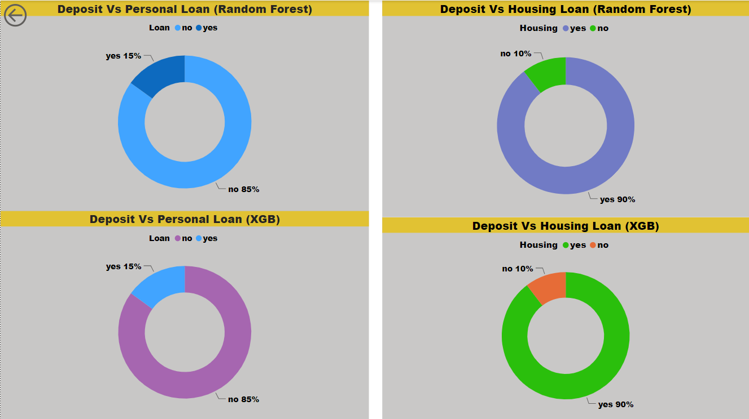

From the Above Insight, It States that: In Deposit Vs Personal Loan and Housing Loan Plot, Random Forest Model predicted as 15% Personal Loan and 90% Housing Loan will be Deposited and XG Boost Model predicted as 15% Personal Loan and 90% Housing Loan will be Deposited.

1. **Deposit Vs Contact (Actual Values)**

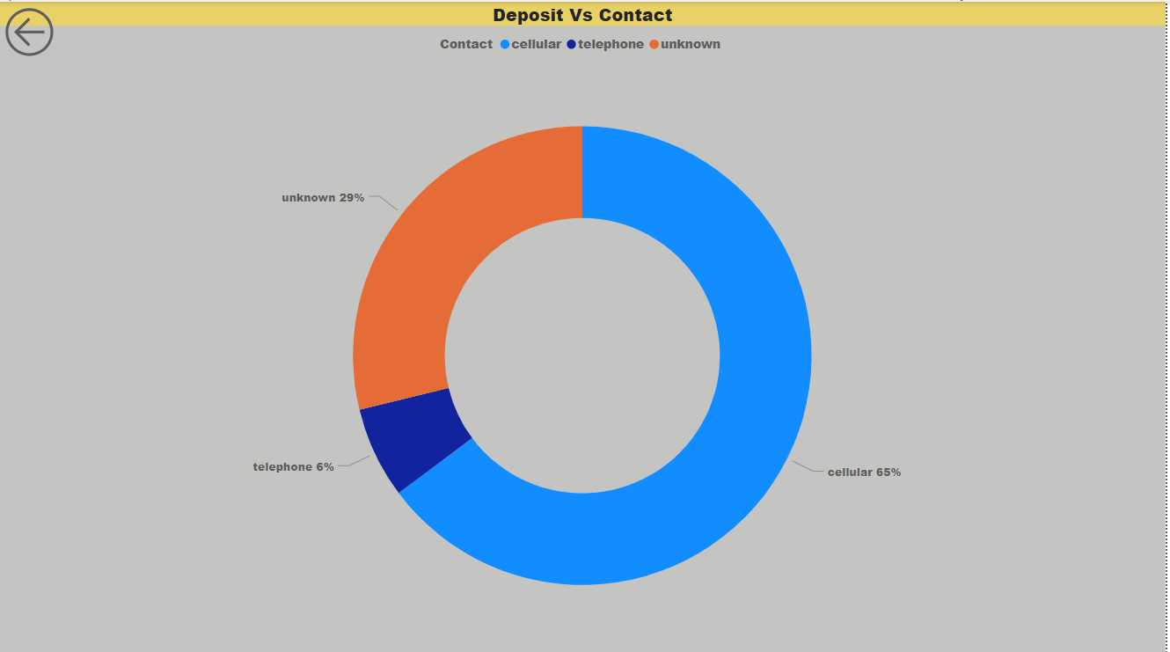

From the Above Insight, It States that: In Deposit Vs Contact Plot, 65% Use Cellular, 28% are Unknown and 6% use Telephone to contact the Bank for Deposit.

(16) **Deposit Vs Contact (Actual Values)**

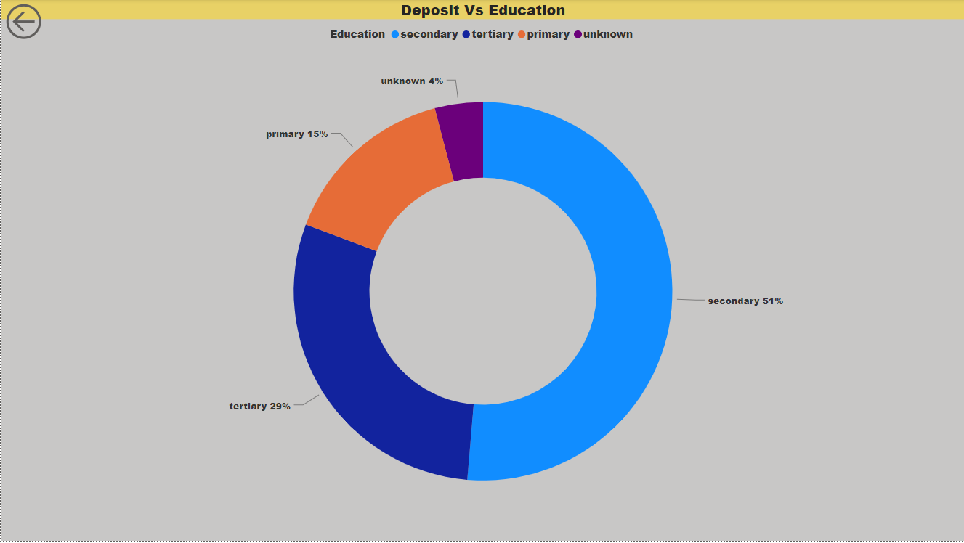

From the Above Insight, It States that: In Deposit Vs Education plot, 51% are Secondary, 29% are Tertiary, 15% are Primary and 4% are Unknown who deposited in the Bank.

(17) **Deposit Vs Martial (Actual Values)**

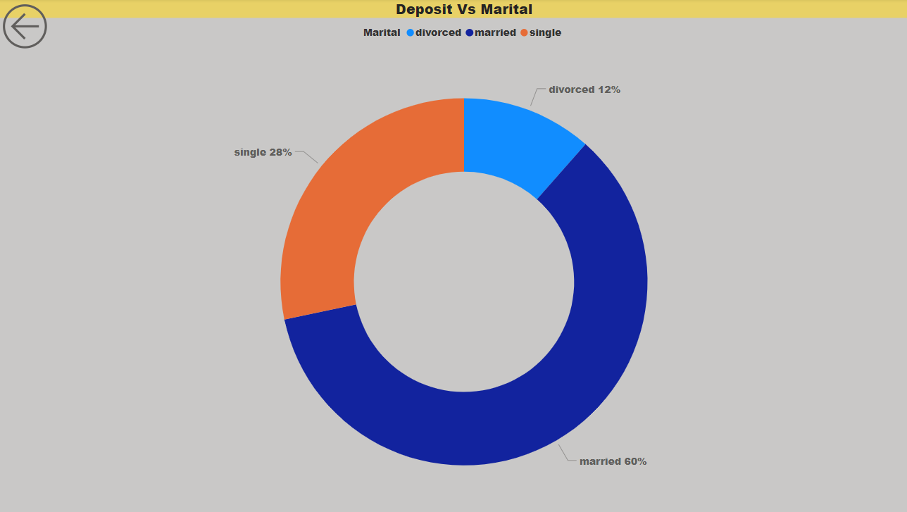

From the Above Insight, It States that: In Deposit Vs Martial plot, 60% are married, 28% are single and 12% are divorced Who Deposited in the Bank.

(18) **Deposit Vs Default (Actual Values)**

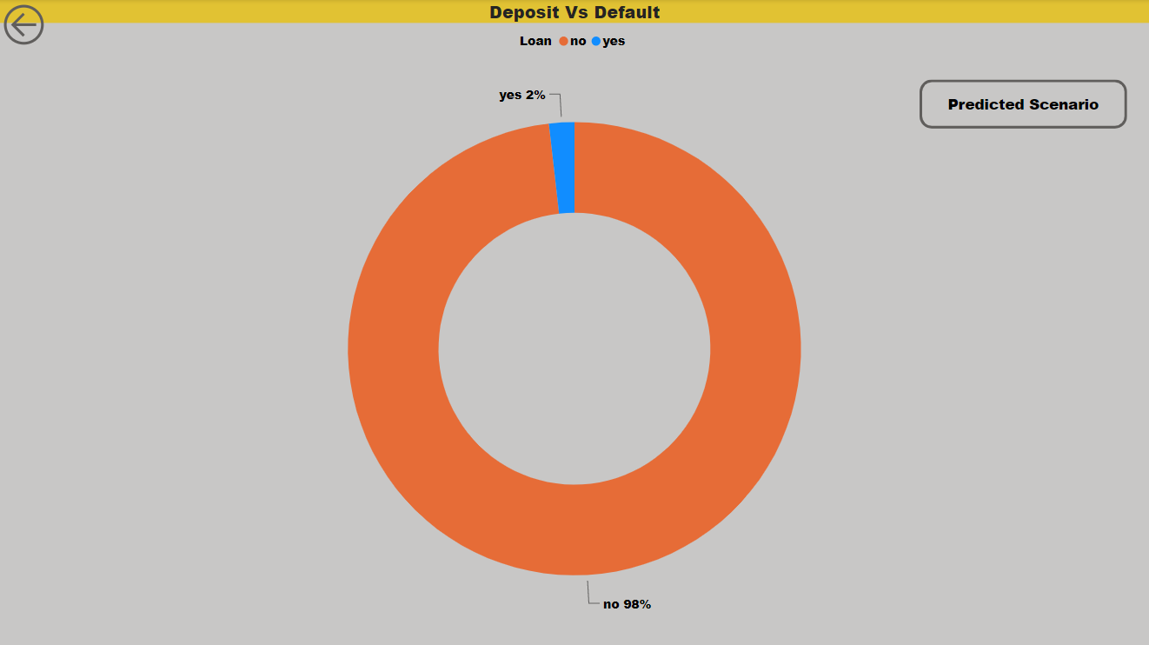

From the Above Insight, It States that: In Deposit Vs Default plot, 2% has defaulted to deposit in the bank.

(19) **Deposit Vs Default (Predicted Values Random Forest and XG Boost)**

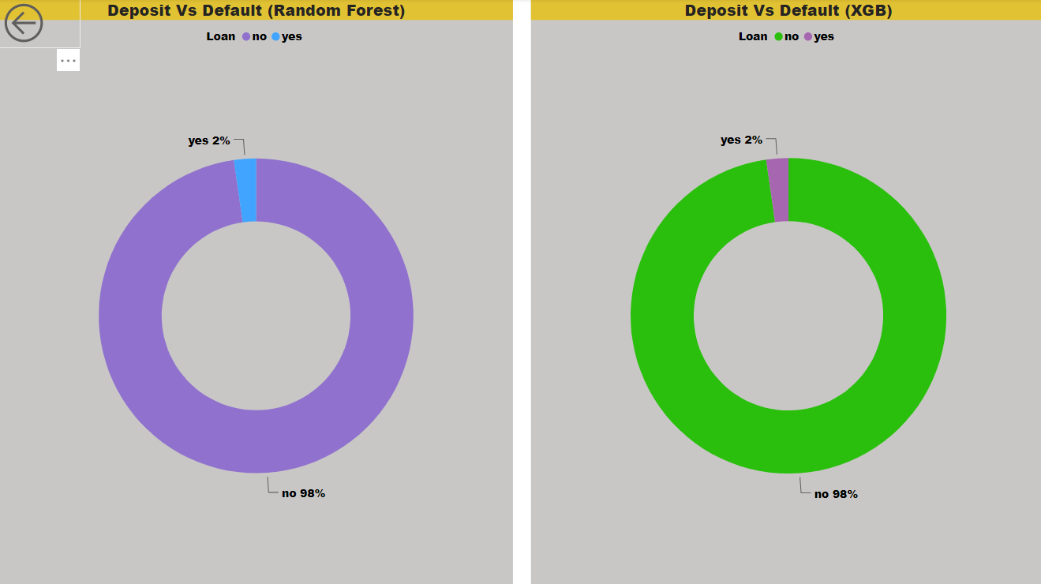

From the Above Insight, It States that: In Deposit Vs Default plot, Random Forest Model predicted as 2% has defaulted to deposit in the bank and XG Boost Model predicted as 2% has defaulted to deposit in the bank.